DAT 520 Milestone Two

Michael Surdek

Southern New Hampshire University

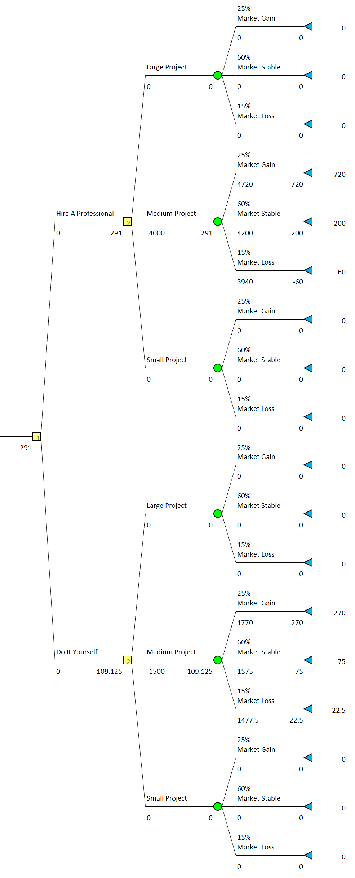

The above decision tree compares the costs and benefits of either hiring a professional or doing it yourself when undertaking a bathroom remodeling project. At its root, the decision tree selects between hiring a professional and doing it yourself depending on which alternative has a higher expected value. The expected values are calculated according to the tree’s branches which are based on the size of the project and the likelihood of various states of nature in the real estate market.

The following estimates show the criteria that has been incorporated into the expected value calculations:

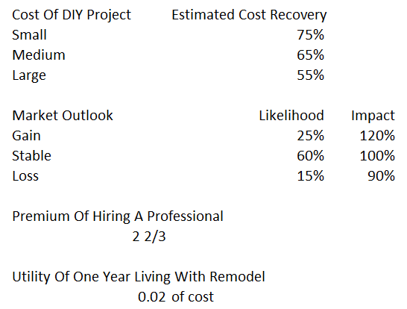

The following shows the inputs that are required to run the decision tree to a specific situation. The amounts shown were used for the above decision tree. The cost of hiring a professional was determined to be about 2 and two-thirds times that of a do-it-yourself bathroom remodel, according to the American Housing Survey 2011 data.

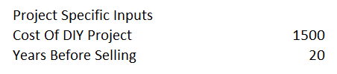

The payoffs at each leaf were calculated as a sum of two parts. The first part comes from the increase in the home’s value from undertaking the project and the second part comes from the utility that is created by having a remodeled bathroom for the remaining years of living in the home. According to the 2019 DIY Remodeling Impact Report from the National Association of REALTORS Research Group, a bathroom remodeling project can recoup between 50-80% of costs in resale value, which smaller projects generally able to recoup a higher percentage. To calculate the increase in the home’s value, I multiplied the cost of the project by the estimated cost recovery and the impact that a gain, stabilization, or loss in the market would have on that value. To calculate the additional utility, I estimated that an improved bathroom is worth about 2% of the cost of the project in utility per year. For example, putting $1000 into a bathroom remodel would add $20 of utility to the payoffs for each year that the individual intends to remain in the home. The expected value of each alternative is determined by multiplying the payoff of each state of nature by its likelihood.

Complications of this analysis process:

* Utility of bathroom remodel
  + It is likely diminishing over time, but is treated as constant in this model
  + Example: Is utility in year 1 = utility in year 10?
  + This model assumes the individual knows how long they will be living in the home before selling, which usually carries significant amounts of uncertainty
* Cost of hiring a professional
  + Estimated as always 2.67 times the cost of DIY based on the median costs, but the data allows me to incorporate the average or possibly the entire distributions
* Market outlook
  + The likelihood of each state of nature could be tied to various estimated times before selling, using conditional probability
* Sequential decisions
  + More goes into this decision that is not currently shown as a node, such as cost of permits and whether the individual even has the ability to do it themselves
  + Does small, medium, or large project count as a decision node? I needed to separate them to account for the different payoff calculations based on the amount of costs they could recoup, but I had to make the non-applicable branches equal to 0, which caused problems when the expected values of the relevant branches were negative.
* Additional utility from hiring a professional
  + Most people would probably be ok with paying a little extra to a professional if the expected values were the same or close. This utility of not having to do the labor yourself is not accounted for anywhere.

The results of the decision tree show that a person who is looking to remodel a bathroom in a home where they will be living for another 20 years, which would cost $1500 to do it themselves, should choose to hire a professional instead of doing it themselves. In this situation, hiring a professional provides an expected value of $291, whereas doing it themselves provides an expected value of only $109. The model provides the decision framework which allowed me to determine that the amount of years required to remain in the home which leads to an equal expected value on a $1500 project is between 16 and 17 years. This means that if the individual intends to stay in the home for 16 or fewer years, they would have a higher expected value if they choose to do it themselves. It is possible to play around with various combinations of the inputs to get an idea of how the alternatives compare to each other in different situations.

The results that I found make intuitive sense, in that the decision point trends towards hiring a professional as the cost of the project and the intended years of living in the home increase. There are possible inaccuracies incorporated into the model that stem from the estimated criteria and the structure of the decision tree. For example, the current calculations include a constant utility per year, premium cost of hiring a professional, market outlook impact and likelihoods, and recoupable costs. All of these factors could be subject to change due to time or other project-specific information. One of the inputs, intended time spent living in the home, could be directly tied to the likelihood of the various states of nature of the real estate market. There is more uncertainty about whether there will be growth in the market over the next 5 years vs the next 25 years. This could be taken into account by using conditional probabilities for the market outlook based on the intended time spent living in the home.

The decision tree also incorporates a decision node that is used to differentiate between small, medium, and large projects. This is not a standard decision, because it is based on the cost of DIY project input, so only one node is relevant to each situation. There are sequential decisions that play a role in determining whether or not to hire a professional, and the structure of the tree could be improved to incorporate the most important ones.

The following tree shows the results for a $3200 project where the individual intends to remain living in the home for 10 years.

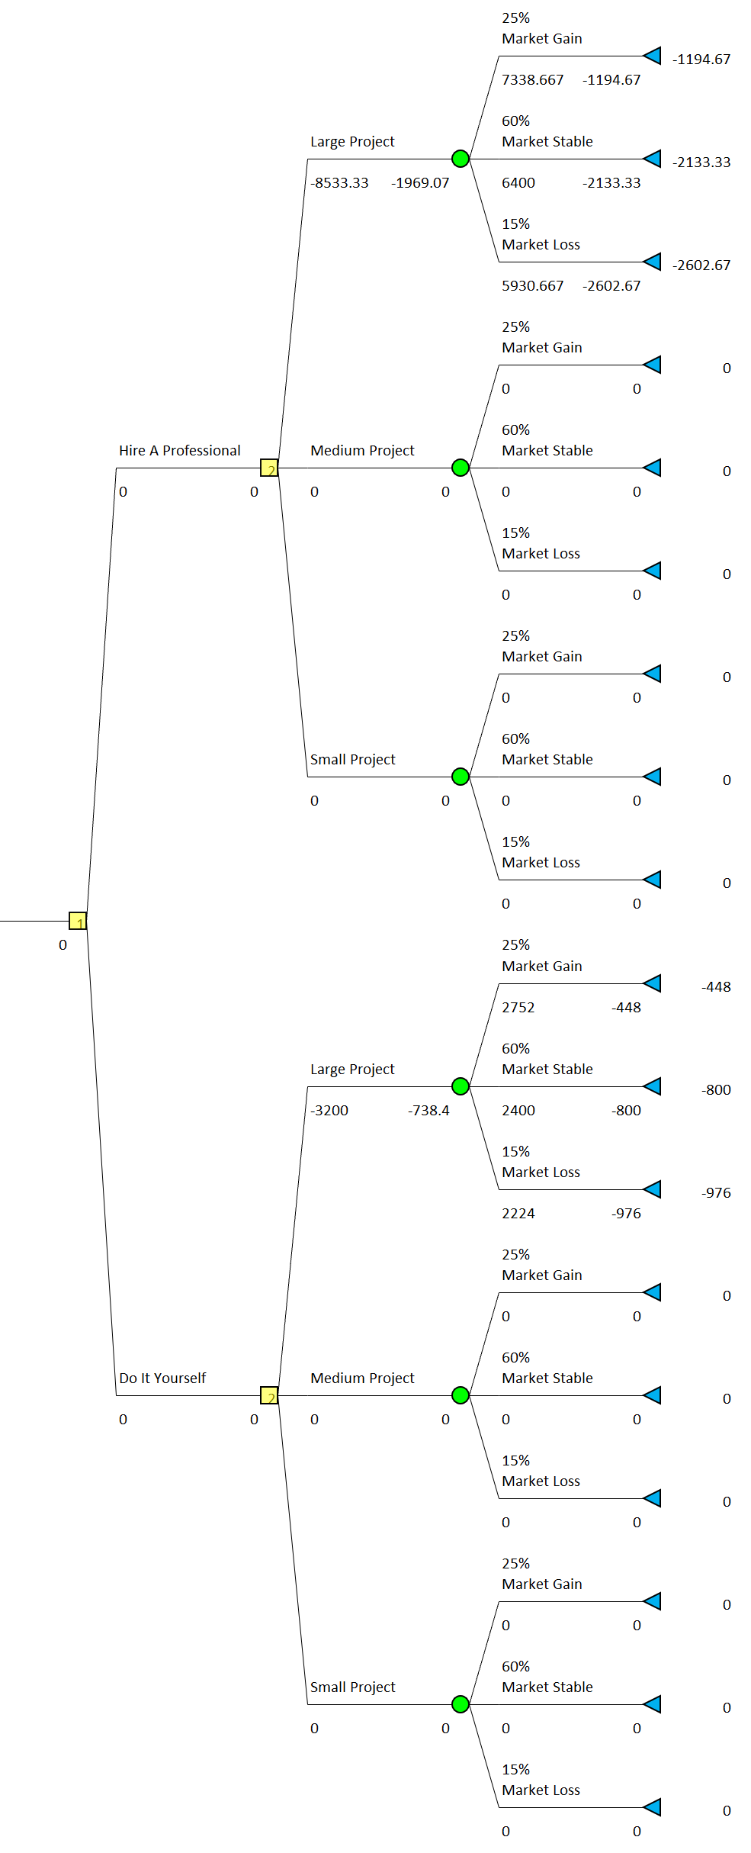

References

American Housing Survey. *2011 Public Use File*. census.gov. 2012. Retrieved from

https://www.census.gov/programs-surveys/ahs/data.2011.html

National Association of REALTORS. *2019 Remodeling Impact Report: DIY*. nar.realtor. 2019.

Retrieved from https://www.nar.realtor/sites/default/files/documents/2019-diy-report-01-

03-2019.pdf